|  |
| --- |
| Circle Language Spec: System Objects |

## System Objects

This chapter tries to demonstrate the internal workings of the symbols and shapes of Circle.

Circle Language Spec's aim is to show the notation of Circle, but this chapter tries to look at the internal workings as if it were an actual program. In doing so, finer details of Circle might start to show. Specifically, the usage of the *'system interface'* might come to light.

This hypothetical implementation supposes, that systems may all be composed of *system objects*. System objects would be the *actual* objects that other systems would be based on.

One of the purposes of system objects might be to manage *relationships* between objects.

A system object may also manage the *system aspects* of a symbol, such as its *class*, whether it *executes* or if it might store a *value*. These aspects could be controlled through *system commands*.

*Assignment commands* may also be system commands. An assignment command might copy an aspect from one object to another.

The *System Objects* documentation would also show *connectors, connections* and other notational forms that might come with controlling system aspects.

### The System Objects

#### The Object

In object oriented programming, an *object* might be considered the most basic element of a computer program. An object might represent a thing, an idea or a place, a number or a collection of other things or possibly anything else. All those things might be called objects.

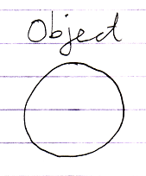

#### The Reference

We might usually be dealing with *references* to objects.

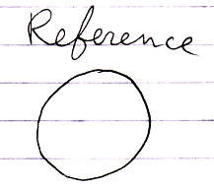

It might also be called a *pointer*.

An object might not be directly accessed. It could be used by other system objects to wrap an object reference into context.

#### Related Object

Another synonym for *object reference* might be *related object*. But a related object would be seen more from the point of view of another object.

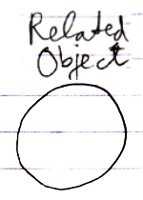

#### Item

Another name for an object might be an item. But perhaps an item is more about an object within a certain *context*.

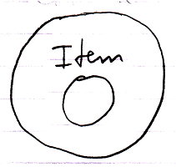

So an item would be like a related object.

#### Related Item

The term *related item* might be synonymous to the term *related object*. A parent object might contain *related items*.

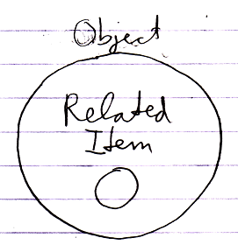

It would be the result of a relationship. A related item might wrap a reference to a related object.

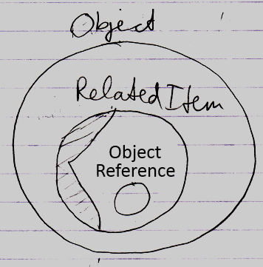

The reference is like a raw pointer, if you can imagine what that might mean, while a related item likes to decorate it with info like its class and perhaps procedures around it, like retrieving the object.

The term *related item* might be used to distinguish it from a *related list*.

#### Related List

A parent object might also contain *related lists*.

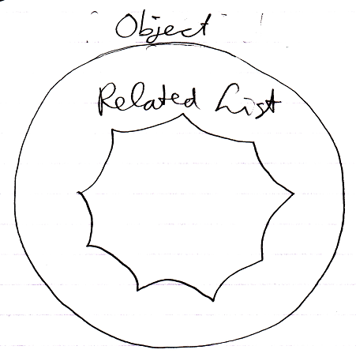

A related list might also be a related object, but perhaps a special one that might contain a scalable collection of other objects.

#### Related List Item

A related list may contain multiple *related list items*.

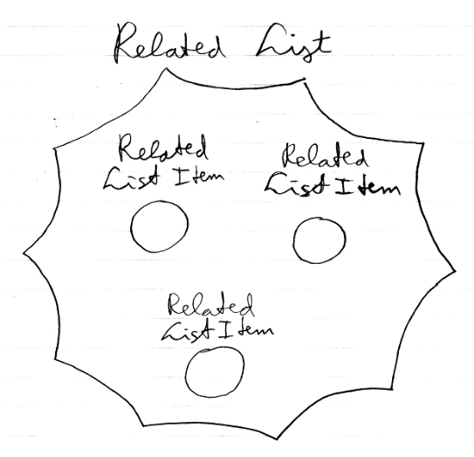

A related *list* itemmight be like a *related item*. What applies to related items might also apply to related *list* items. In some cases though, the behavior may be different.

#### Related Items & Related Lists Collections

An object’s related items and related lists might be stored as an object’s containing two collections: **Related Items** and **Related Lists**. The **Related Items** collection would contains all the related items of the object. The **Related Lists** collection would contain all the related lists of the object.

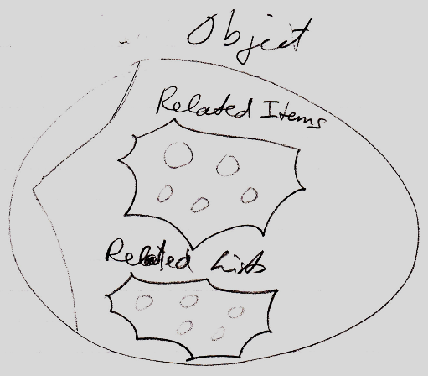

#### Reflective Data

To have a related items collection and a related list collection under the hood of a symbol, might just be an arbitrary choice. It favors the distinction between **1** related item and **n** related items.

There could be other variations on that.

One variation might be one where there is a single related objects collection:

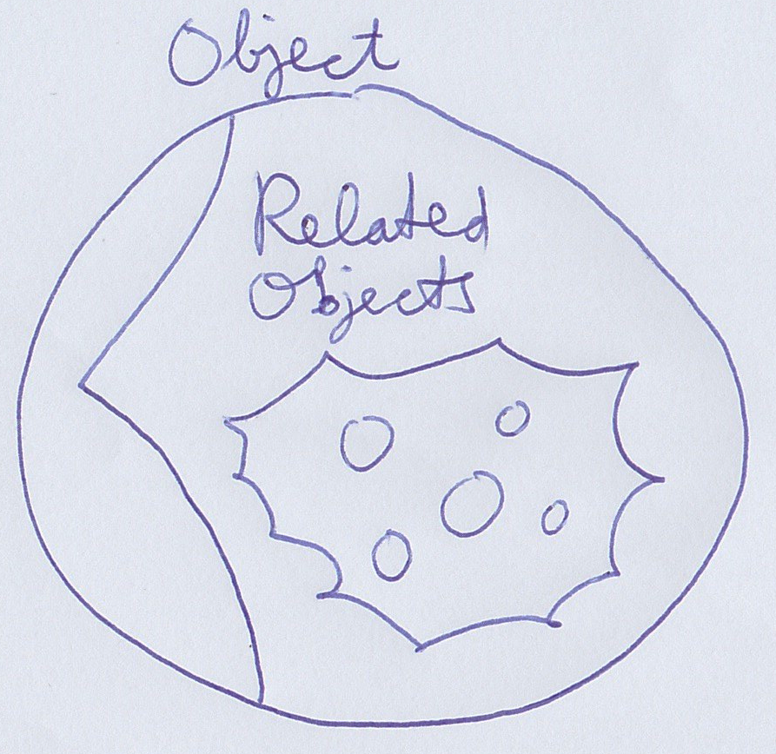

Lists might also be in the same collection. The single related objects collection might simply contain both lists and single items in a single place.

Another variation might add another collection:

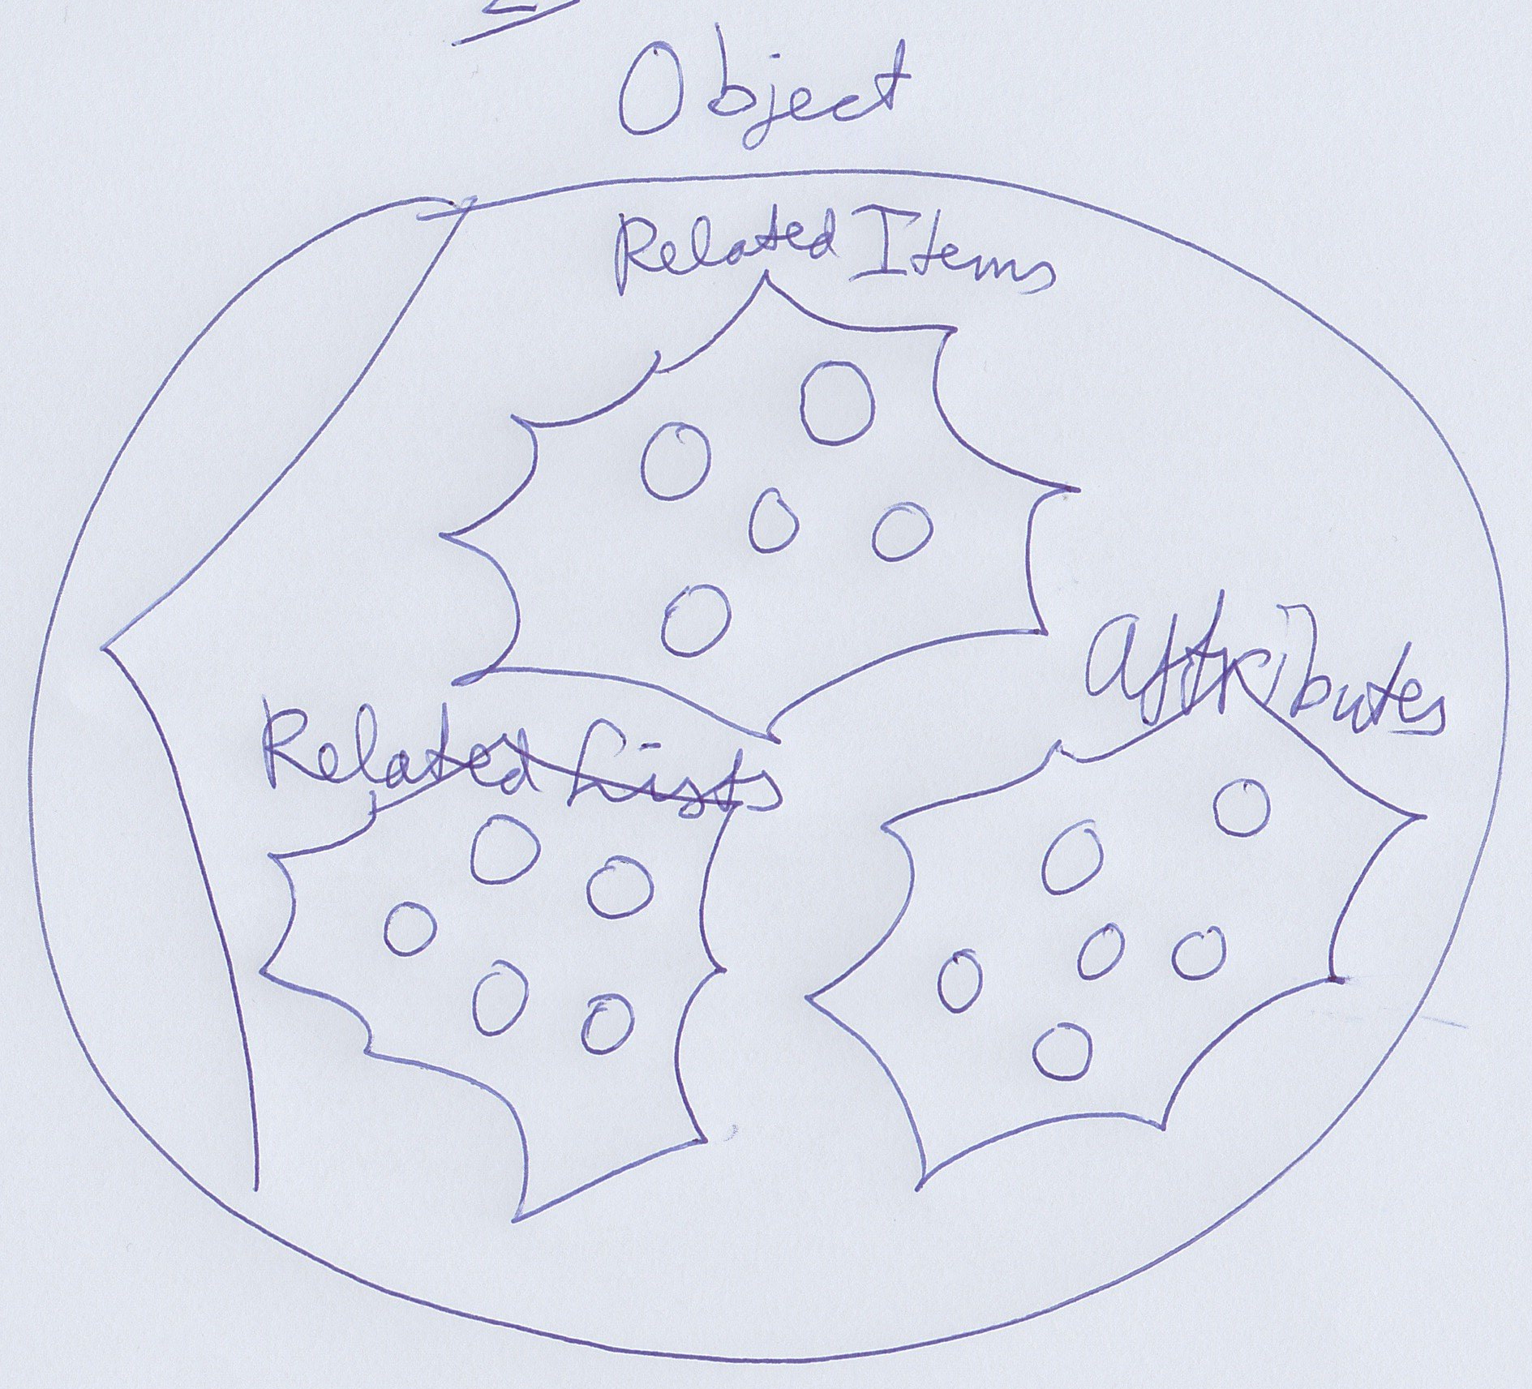

Here next to **Related Item**s, **Related Lists** there would be **Attributes**: basically the collection of simple loose values the object might hold.

It might go on. A **Commands** collection might be added for instance, to perhaps list sub-objects that are command symbols.

By now the suspicion might be, that it could be a quite arbitrary choice of collections.

An alternative could be that there is one collection of related objects, but separate enumerators to retrieve related lists, related items, attributes and commands separately.

This 'under the hood' data might be called reflective data by some. There are other systems, where you can take a class and retrieve separate lists of properties and methods for instance and the ability to read out the values or call the methods. That idea might be closely related to this one here. That way you might tap into data more generically based on characteristics, rather than pointing at specific objects.

#### Symbol

The term *symbol* mightbe used as a synonym for related item or for object. But there might be a subtle difference that a symbol might just be a shape displayed on screen. The same related item could be displayed on screen multiple times.

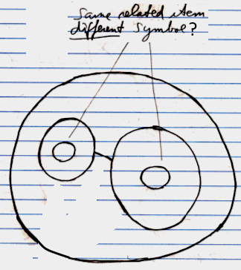

But the difference might be too subtle to talk about. A symbol might not be a system object, it might just a shape displayed on screen.

#### System Object

The terms above indicate different kinds of *system objects*, except for maybe the term *symbol*.

#### Summary

All the objects in this imaginary implementation of Circle might live as these system objects.

Here is a recap of terms introduced in this section:

**Object**

**Item**

**Reference**

**Related Object**

**Related Item**

**Related List**

**Related List Item**

**Related Items & Related Lists Collections**

**Reflective Data**

**Symbol**

**System Object**

### System Aspects

The behavior of objects, references and lists might be controlled by controlling their *aspects*. This section tries to list out various aspects of objects, references and lists. The pictures try to show a bit of each aspect’s diagram symbolization.

#### Object

The **Object** aspect may determine which object is pointed to.

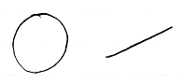

#### Class

The **Class** aspect might determine which other object would function as the prototype or class of another object. It can also bind a reference to a class.

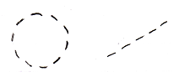

#### Interface

The **Interface** aspect might give control over how objects might look on the outside, while the insides of the objects may be different. The **Interface** aspect should be covered in the *Interfaces* chapter, and might not be mentioned any further in this chapter.

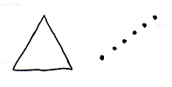

#### Value

The **Value** aspect might allow storing binary content and might allow yielding over values from one object to another.

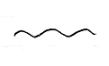

#### Execute

The **Execute** aspect might be about the ability to execute an object as a command.

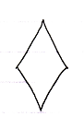

#### List

The **List** aspect may allow adding and removingitems from a list.

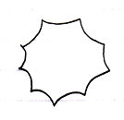

#### Name

The **Name** aspect may allow giving names to objects, lists and references.

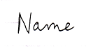

#### Existence

The **Existence** aspect might allow creating a new object. An object reference might also be annulled. Then it may point to nothing. Another option might be the ability to *check* whether an object reference "**Nothing**"or"**null**".

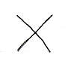

#### Data

With the data aspect the idea is to control reading or writing access. Instead of being able to access-control a single object, the **Data** aspect might control read-write access to all of the sub-objects as well.

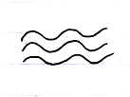

#### Clone

The proposed **Clone** aspect might be related to the **Value** aspect, but might also copy values of sub-objects.

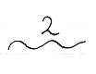

Its use might be that it may occur periodically that you might want to copy an object + its child values.

#### Summary

Here is an attempt to list the aspects again:

**Object**

**Class**

**Interface**

**Value**

**Execute**

**List**

**Name**

**Existence**

**Data**

**Clone**

### Object-Bound & Reference Bound Aspects

When using *system aspects*, there seems to be a subtle phenomenon that some aspects might to be bound to an *object*, while other aspects may be bound to a *reference*.

Object-bound aspects would be determined by an object. An object might also control its sub-objects’ reference-bound aspects. Therefore *reference-bound* aspects might also be called *sub-object-bound* aspects.

The following aspects may be object-bound:

**Value**

**Class**

**Execute**

**Clone**

**Data**

**List**

The following aspects might be reference-bound (or *sub-object-bound*):

**Object**

**Existence**

**Class**

**Name**

The **Class** aspect seems to be both object-bound as well as reference-bound. (The **Interface** aspect too, but that topic may be saved for later.)

The idea of object-bound aspects might help an object protect some of its characteristics and not be different depending on which object reference points to it.

An object seems to control its object-bound aspects as well as its sub-objects’ reference-bound aspects.

### System Commands

System *commands* could be the commands of system objects, through which aspects of objects may be controlled.

Aspects may be given **Get** and a **Set** command, though each aspect may be controlled in a different way.

#### System Commands for the Object Aspect

The main two system commands for the **Object** aspect are:

**Object Get**

**Object Set**

**Object Get** retrieves the targeted object of a reference.

**Object Set** changes an object reference target.

#### System Commands for the Class Aspect

The main system commands to control the **Class** aspect are:

**Use As Class**

**Class Set**

**Reference-Class Get**

**Object-Class Get**

**Use As Class** is like **Object Get**, but then for the purpose of using that object as the class of another object. This is common usage of the class aspect. It also makes you able to separately access control whether an object can be used as a class.

The **Class Set** command is executed on an object reference. The reference can then only point to objects of that class. **Class Set** applies only to references, and not to objects, because the class of an object is only set upon creation.

The commands **Reference-Class Get** and **Object-Class Get** getthe class object that is associated with a reference or object. Those commands are actually less commonly used.

##### Class is both Object-Bound and Reference-Bound

The **Class** aspect applies to both objects and references, but differently. An object has a certain class, which is fixed upon creation of the object and throughout its lifetime. A reference also has a class, defining which class of object you can assign to the reference. The class of an *object* can never change. The class of a reference can be changed, but only while the reference is **Nothing**. You can not change the class of a reference when an object is assigned to it, except that you can set it to **Nothing** or to the same class as the object again.

Even though the **Object-Class** and **Reference-Class** are the same or one or the other is not filled in, objects and references still each need to separately store which class they have.

##### The Overloads Recapitulated

This leaves us with the following commands:

**Use As Class**

**Class Set**

**Reference-Class Get**

**Object-Class Get**

#### System Commands for the Value Aspect

The **Value** aspect is controlled through two system commands:

**Value Get**

**Value Set**

**Value Get** gets the value of an object.

**Value Set** sets the value of an object.

#### System Commands for the Clone Aspect

The **Clone** aspect is controlled through two system commands:

**Clone Get**

**Clone Set**

The **Clone** aspect is related to the **Value** aspect, but will also copy the sub-objects’ values. **Clone** has a parameter, that defines the cloning depth: the depth at which to clone sub-objects. When the cloning depth is **2**, then this is also expressed as:

**Clone (2) Get**

**Clone (2) Set**

**Clone Get** copies the object and sub-objects. **Clone Set** assigns the cloned values to another object. This can also be a new object.

#### System Commands for the Name Aspect

The **Name** aspect is controlled through two system commands:

**Name Get**

**Name Set**

**Name Get** gets the name of an object, reference or list.

**Name Set** sets the name of an object, reference or list.

#### System Commands for the Data Aspect

The **Data** aspect is controlled through two system commands:

**Data Get**

**Data Set**

**Data Get** and **Data Set** can not be called. They can only be access-controlled. By access‑controlling them you are access controlling being able to read or write to any sub-object or deeper object. The **Data Get** command abstractly represents any *read*, in other words: any possible **Get** call to any sub-object. The **Data Set** command abstractly represents any *write* to any sub-object.

#### System Commands for the Execute Aspect

The **Execute** aspect is controlled through one system command:

**Execute**

You can access control being able to execute a command. Some commands are never meant to be executed, because they are a definition.

#### System Commands for the Existence Aspect

The **Existence** aspect is controlled through the following system commands:

**New**

**Annul**

The **New** command has an optional **Class** argument, with which you can indicate the class to create a new **Object** from.

There is also the system attribute **Is Something** which returns **True** or **False**, also represented by the terms **Something** or **Nothing**.

#### System Commands for the List Aspect

The **List** aspect is controlled through the following system commands:

**Add**

**Remove**

The **Add** command is part of a **List** object. The **Add** command adds an item to the list. This may be an existing item, passed through the optional argument **Item**. You can also create a new item for it, possibly of a new class, using the **New** command, which is part of the **Existence** aspect.

The **Remove** command is part of a **Related List Item**. It removes that item from the list.

### System Interfaces

#### Main Concept

##### System Interface Notation

Usually you see an object’s members:

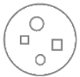

But all objects, references and lists are based on system objects. You can also show the members of the system object instead. You can do that by breaking open the inner workings of the objects and show the *system interface*:

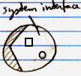

When the system interface is shown, the normal members are not visible anymore.

##### Example: System Interface of an Object

An **Object** might normally look like this:

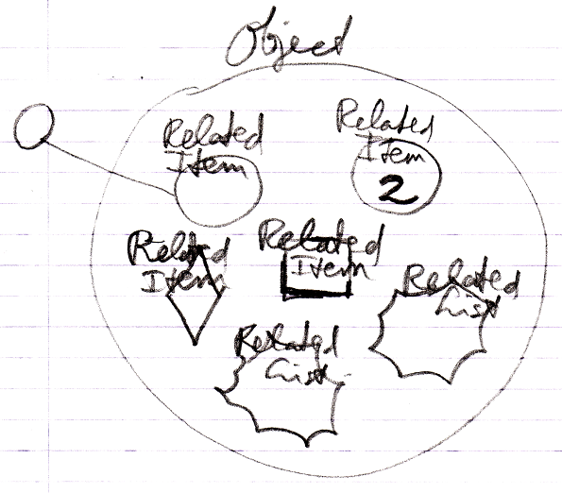

But if you open up an **Object's** system interface, then the related items and related lists are shown as the **Related Items & Related Lists** collections:

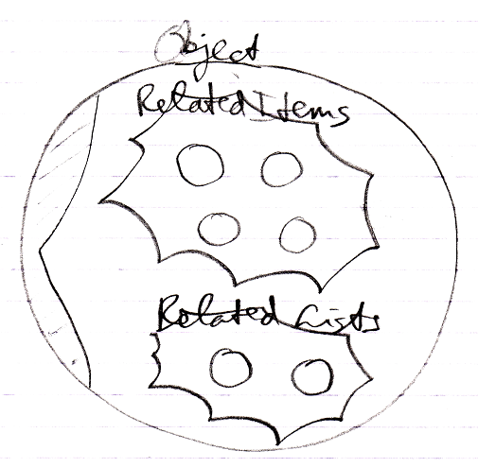

The **Related Items** and **Related Lists** are now displayed as circles: normal objects, even when they are *commands* and even when they are *lists*. This only represents the exact way an **Object** actually internally works.

##### Aspects

Next to controlling *sub-objects*, the system interface also controls *aspects*, for instance, the **Value** aspect:

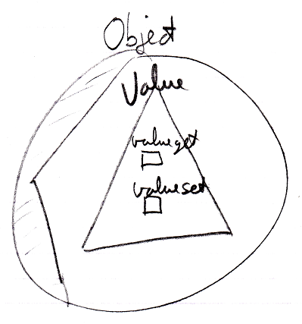

##### System Interface = Publics of System Objects

Everything about system interfaces is based on the fact that the system interface is nothing more than the public members of a system object. Even when the explanation about system interfaces is incomplete, what is missing can be derived from the fact, that the system interface will simply show all the public members of a system object. You should also realize that the *private* workings of system objects are not shown in the system interface.

##### Origin of the System Interface Notation

The notation of the *system interface* is derived from the *interface* notation. When an object has several interfaces, each interface is shown as a triangle inside the object:

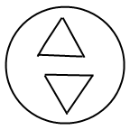

But showing the system interface is like showing the interior ‘of the symbol itself’. Therefore, the triangle of the system interface is now stuck to the border of the symbol:

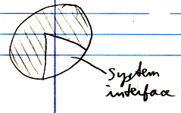

That way the interface is more part of the object itself, rather than being a sub-object.

To make more room inside the system interface the following, exaggerated notation is used:

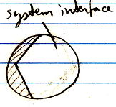

It also looks as if you have broken open the shell of the symbol to see its inner workings. It looks like you have opened up the system and can see its internal wiring. The system interface is like seeing the setup of the symbol machine.

#### System Interface of an Object

The main thing you see when showing the system interface of an **Object** is the **Related Items & Related Lists** collections.



But apart from sub-objects, an object has the following aspects:

**Value**

**Class**

**Execute**

**Clone**

**Data**

They are controlled through system commands. Those commands will also be visible inside the system interface.

##### The Value Aspect in the System Interface

The **Value** aspect is controlled through two commands:

**Value Get**

**Value Set**

The **Value** aspect is represented by a triangle, that wraps together the members to control the **Value** aspect:



##### The Object-Class Aspect in the System Interface

The **Class** aspect has *several* system commands, but only *two* of them apply to **Objects**. The other ones apply to references. The **Class** aspect of an **Object** is controlled through the following commands:

**Use As Class**

**Object-Class Get**

The commands are placed inside a triangle, that wraps together the members of the **Class** aspect:

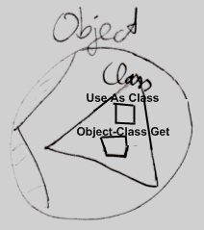

##### The Execute Aspect in the System Interface

The **Execute** aspect only applies to executable objects, also called commands. The **Execute** aspect only has one command:

**Execute**

The command is placed inside a triangle, that wraps together the members of the **Execute** aspect:

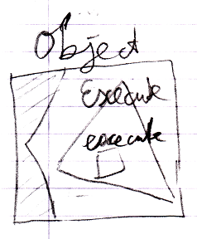

##### The Clone Aspect in the System Interface

The **Clone** aspect is controlled through two commands:

**Clone Get**

**Clone Set**

Both commands have a **Depth** parameter to indicate the cloning depth.

The commands are placed inside a triangle, that wraps together the members of the **Clone** aspect:

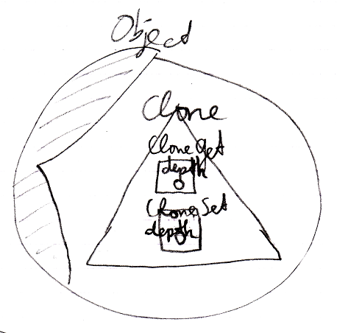

##### The Data Aspect in the System Interface

The **Data** aspect is controlled through two system commands:

**Data Get**

**Data Set**

The **Data Get** and **Data Set** command can not be called; they can only be access-controlled to control read-write access to the object and all the contents of the object.

The commands are placed inside a triangle, that wraps together the members of the **Data** aspect:

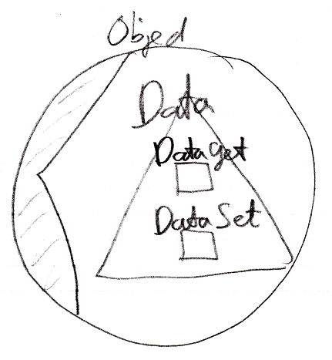

##### The Full System Interface for Object

The full system interface of an **Object** looks like this:

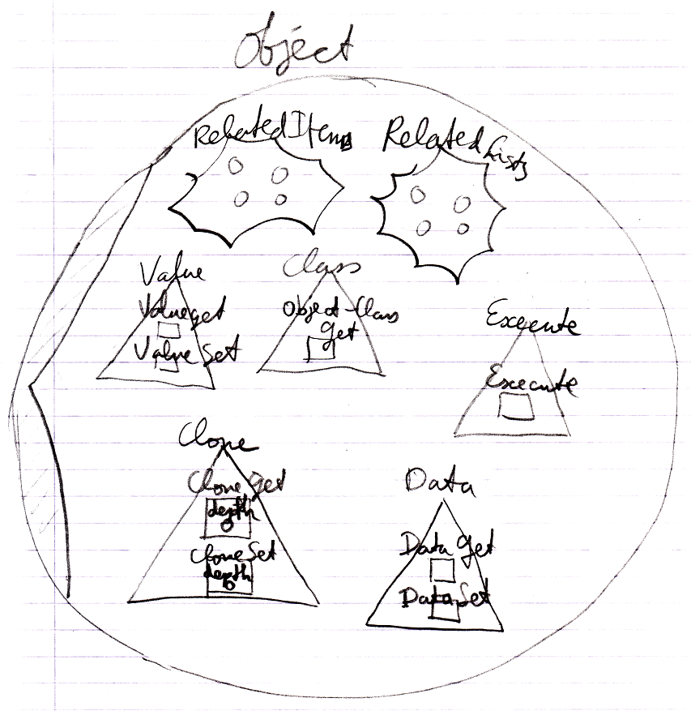

#### System Interface of a Related Item

When you open up the system interface for a **Related Item**, you get to see the system commands that apply to **Related Items**. Aspects, that apply to a **Related Item** are:

**Object**

**Existence**

**Class**

**Name**

##### The Object Aspect in the System Interface

The **Object** aspect of a **Related Item** is controlled through several commands:

**Object Get**

**Object Set**

The commands are placed inside a triangle, that wraps together the members of the **Object** aspect:

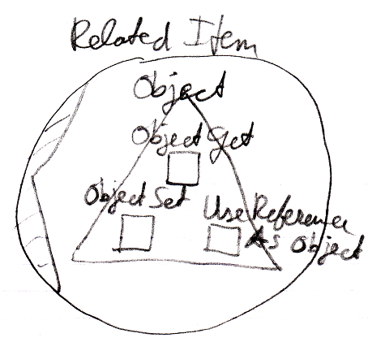

< Erase "Use Reference As Object"? >

##### The Existence Aspect in the System Interface

The **Existence** aspect is controlled through two commands and an attribute:

**New**

**Annul**

**Is Something**

The members are placed inside a triangle, that wraps together the members of the **Existence** aspect:

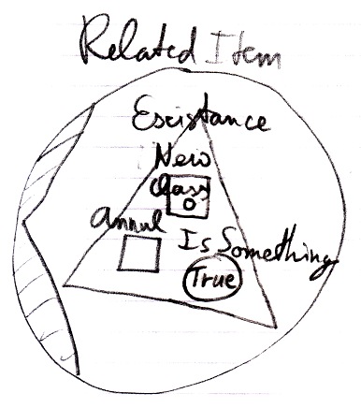

##### The Reference-Class Aspect in the System Interface

The **Class** aspect has *five* system commands, but only *three* of them apply to **Related Items**:

**Class Set**

**Reference-Class Get**

The commands are placed inside a triangle, that wraps together the members of the **Class** aspect:

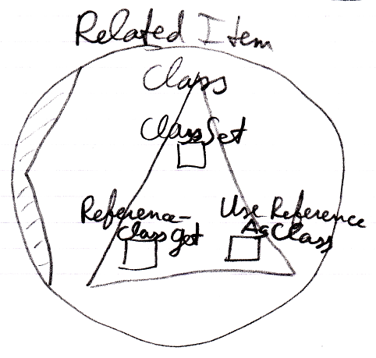

< Erase "Use Reference As Class"? >

##### The Name Aspect in the System Interface

The **Name** aspect is controlled through two commands:

**Name Get**

**Name Set**

The commands are placed inside a triangle, that wraps together the members of the **Name** aspect:

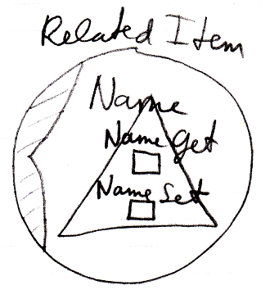

##### The Full System Interface for Related Item

The full system interface of a **Related Item** looks like this:

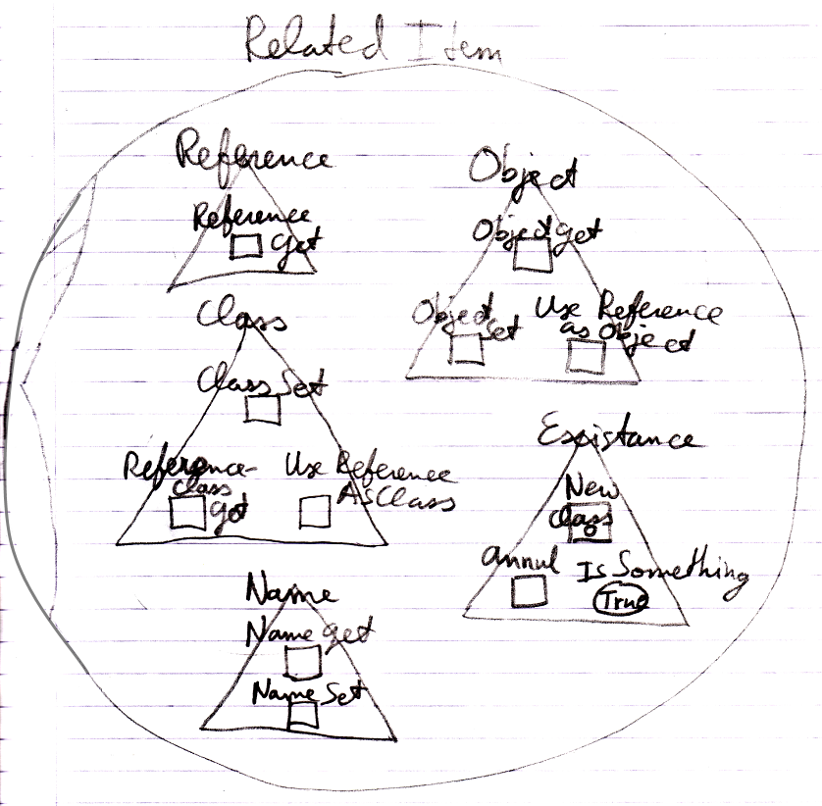

< Erase "Reference", "Use Reference As Object" and "Use Reference As Class"? >

#### System Interface of a Related List

When you open up the system interface for a **Related List**, you get to see the system commands that apply to **Related Lists**. Only the **List** aspect applies to **Related Lists**. The system interface of a **Related List** will show the **Add** command. The **Add** command has an optional **Item** argument, to add an existing item to the list.

So the system interface of a **Related List** looks like this:

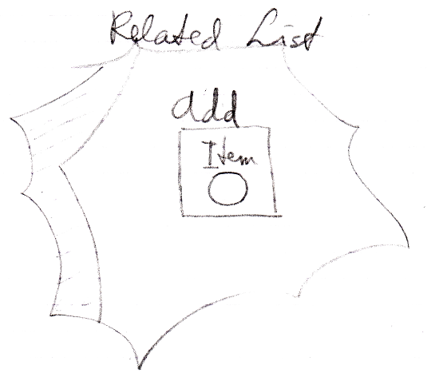

But more members may be introduced later. Specifically you probably would want to centrally control the **Class** aspect of all the items in the list.

#### System Interface of a Related List Item

When you open up the system interface for a **Related List Item**, you get to see the system commands that apply to **Related List Items**. Aspects, that apply to a **Related List Item** are:

**Object**

**Existence**

**Class**

**List**

Those are the same as a **Related Item**, minus the **Name** aspect, plus the **List** aspect.

Only the **List** aspect for the **Related List Item** is explained here. The other aspects were already worked out in the section *System Interface for Related Item*.

##### Related List Item’s List Aspect in the System Interface

The **List** aspect of the **Related List Item** is represented by:

**Remove**

The command, which removes the item from the list

**List**

A reference to the **List** that the **Related Item** is part of.

The members are placed inside an interface, that wraps together the members of the **List** aspect:

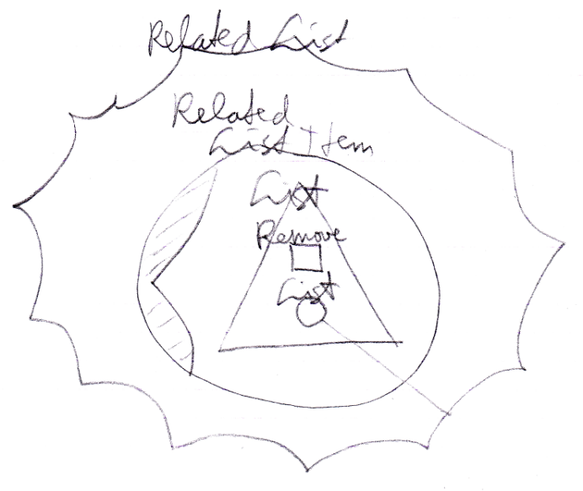

##### The Full System Interface for Related Item

A **Related List Item** is almost the same as a **Related Item**, so the full system interface of a **Related List Item** also shows all the other aspects:

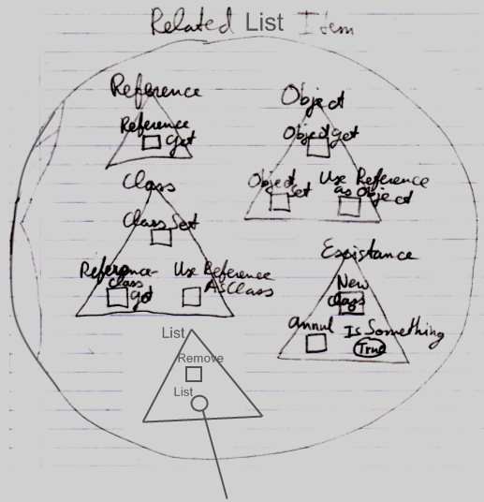

< Erase "Reference", "Use Reference as Object" and "Use Reference as Class"?>

#### Use-Command Gets Another Aspect

The **Use As Class** command is part of the **Class** aspect but **Gets** the **Object** aspect.

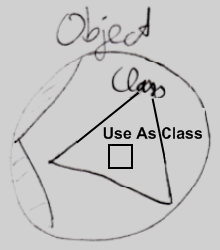

A **Use** command **Gets** a different aspect than what it applies to. The **Use Reference As Object** command is part of the **Object** aspect but **Gets** the **Reference** aspect. The **Use Reference As Class** command is part of the **Class** aspect, but **Gets** the **Reference** aspect. < Is it an idea to reword this to something about the **Use As Class** command instead? >

How a **Use** command delegates to a **Get** command of the other aspect is not visible in the system interface, because that is private implementation. You only get to see the public members of the system objects, not their implementation.

#### Aspect-In-A-Triangle

An aspect is represented by a triangle containing system commands:



It was a design choice to have system commands placed inside a triangle, that represents the aspect, because it does not always look best to explicitly qualify each **Class** command with "**Class .**" So you can directly call the **Use As Class** command and not use something like:

**Class . Use As Class**

**Class . Use Object As**

**Object . Use As Class**

That last one *looks* fine, but places a class-related action inside the **Object** aspect, which you do not want, because you want to keep all commands that apply to the **Class** aspect together under the **Class** aspect.

All-in-all: this is a design choice.

#### System Interfaces of Objects and References

There are system commands that apply to **Objects** and system commands that apply to **References**, but when you show the system interface of a symbol, which do you show? The system interface of the **Object** or the system interface of the **Reference**?

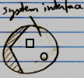

The solution for this problem is that you always deal with *references* to objects, never with the object directly, so when you open up the system interface of a symbol, the system interface of the **Reference** is shown. However, inside of it you will find the referenced **Object**, showing its system interface.

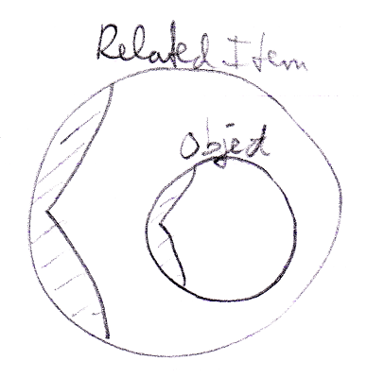

#### Preliminariness of the System Interface Notation

The basics of the system interface notation are not preliminary. But the system interface shows the exact public members of the code base objects. If the code base were to be programmed differently, the system interface members will also look different. Design choices were made in this documentation, which influenced the notation of the system interface members. Perhaps when implementing the code base in the future, different design choices are made and that will change the way the system interfaces look.